## Problem 1 – Beats Product Page

Create a Web page (HTML5 + CSS3 + images) that looks and behaves like the screenshots below: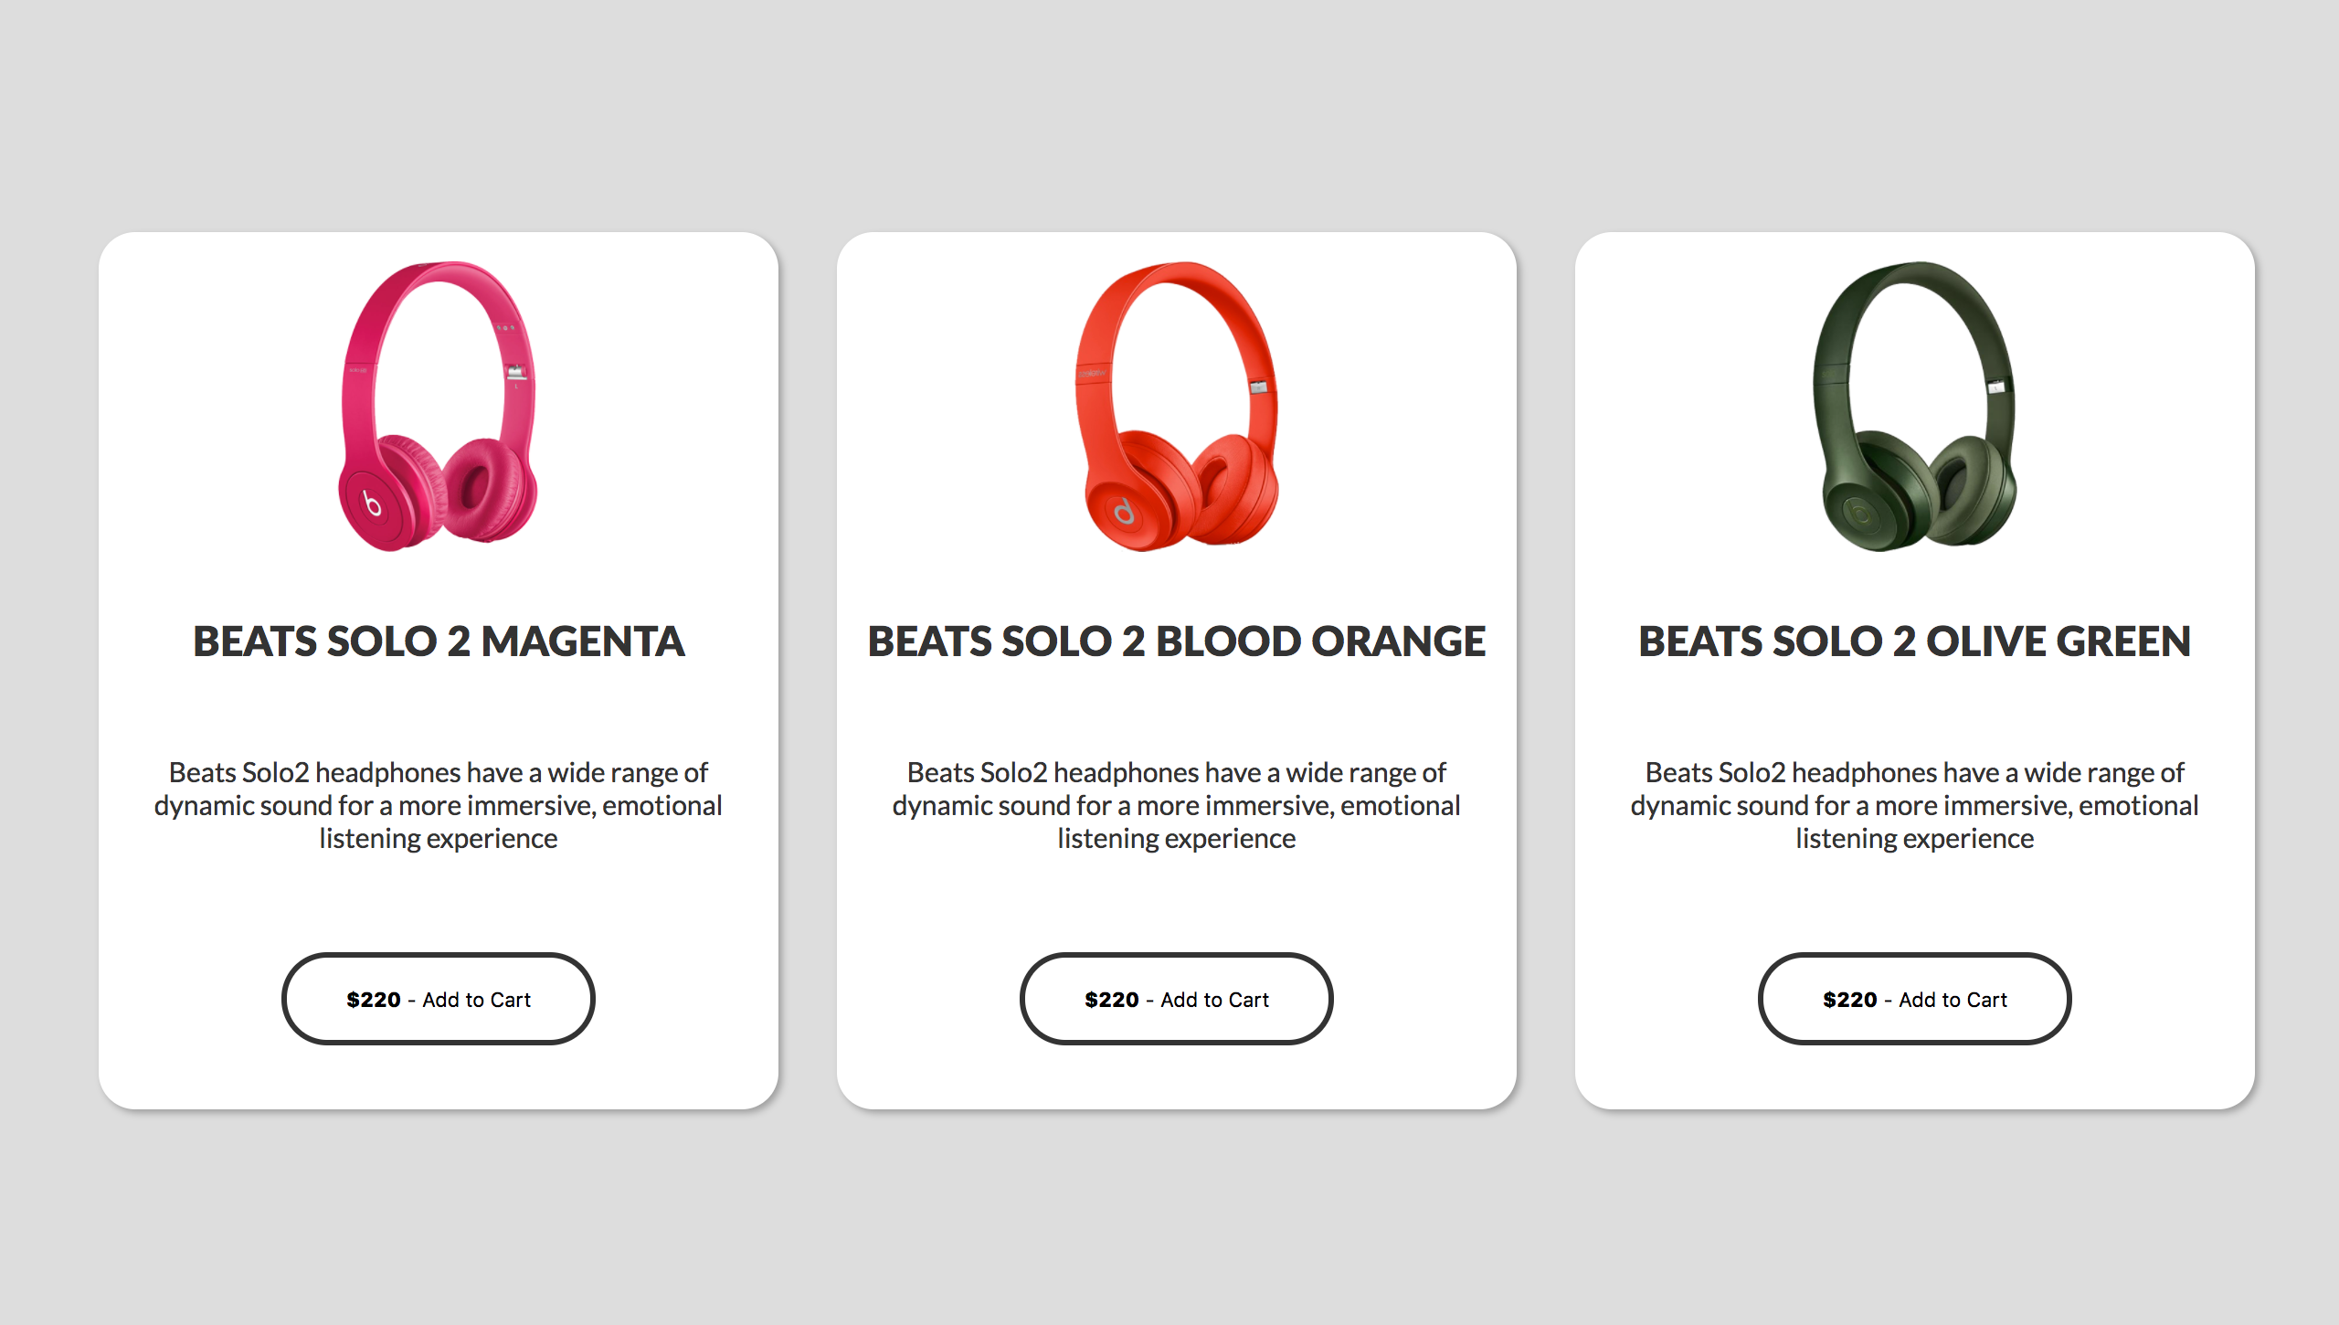

### Input

You are given the above screenshots + all required images + the texts on the site.

### Output

The output should be valid HTML5 + CSS3 + images that implement the above Web page.

### Constraints

* Use google font **Lato** - https://fonts.googleapis.com/css?family=**Lato:400,900**
* Pixel-perfect implementation is not required.